Huỳnh Ngọc Quang – SE181838

NWC204 - dunglt92

Lab - Basic Switch and End Device Configuration

## Set Up the Network Topology

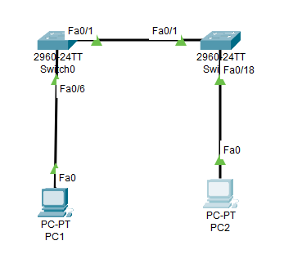

## Configure PC Hosts

* + 1. Configure static IP address information on the PCs according to the Addressing Table.

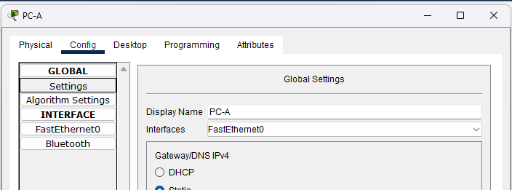

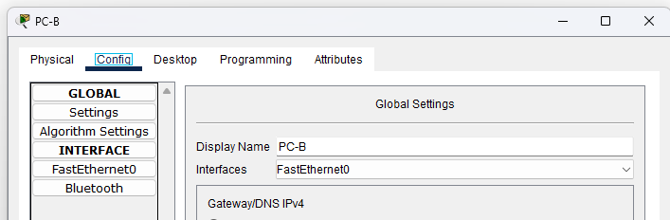

* + 1. Verify PC settings and connectivity.

## Configure and Verify Basic Switch Settings

* + 1. Console into the switch. Enter the global configuration mode.

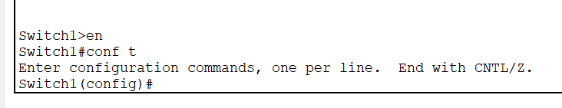

Open Configuration Window

* + 1. Give the switch a name according to the Addressing Table.

* + 1. Prevent unwanted DNS lookups.

* + 1. Enter local passwords. Use **class** as the privileged EXEC password and **cisco** as the password for console access.

* + 1. Configure and enable the SVI according to the Addressing Table.

* + 1. Enter a login MOTD banner to warn about unauthorized access.

* + 1. Save the configuration.

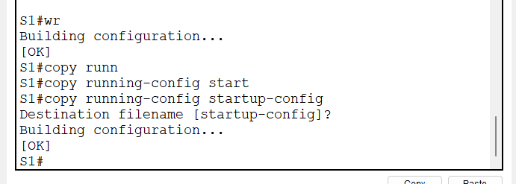

* + 1. Display the current configuration.

* + 1. Display the IOS version and other useful switch information.

* + 1. Display the status of the connected interfaces on the switch.

Close Configuration Window.

* + 1. Configure switch S2.
    2. Record the interface status for the following interfaces.

| Interface | S1 Status | S1 Protocol | S2 Status | S2 Protocol |
| --- | --- | --- | --- | --- |
| F0/1 | Up | Up | Up | Up |
| F0/6 | Up | Up | Down | Down |
| F0/18 | Down | Down | Up | Up |
| VLAN 1 | Up | Up | Up | Up |

* + 1. From a PC, ping S1 and S2. The pings should be successful.

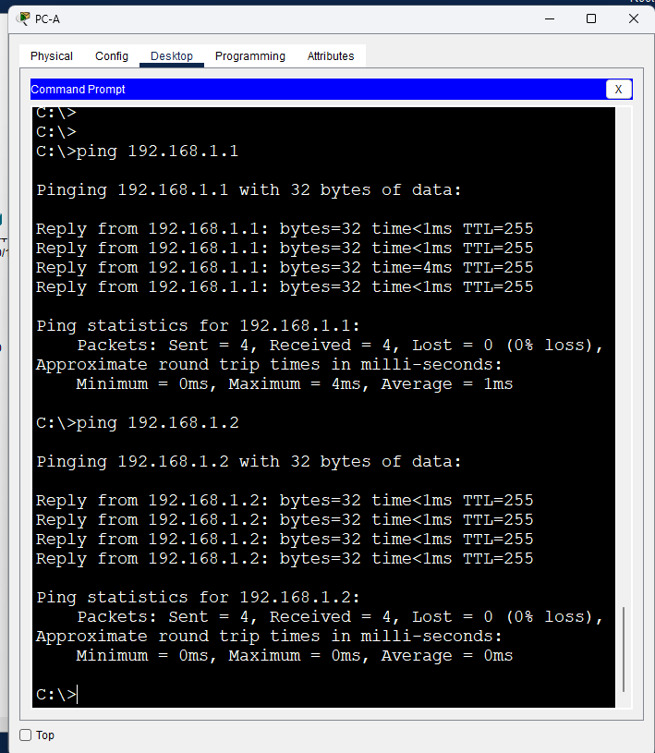

* + 1. From a switch, ping PC-A and PC-B. The pings should be successful.

# Reflection Question

Why some FastEthernet ports on the switches are up and others are down?

* The FastEthernet ports remain in an active state if there are cables connected to them, unless the administrators intentionally disable them. If not, the ports will be in an inactive state.

What could prevent a ping from being sent between the PCs?

* Wrong IP address configuration, media disconnected, switch powered off or ports administratively down, firewall, ....